Heartquake
Primary School Lesson Plan

I am not what happened to me, I am what I choose to become

Overview:

With natural disasters the focus is usually on the event itself. After the event the media focus often moves onto the next issue. The resilience and hard work that is undertaken to restore a new normal is not seen. Through this lesson, students can begin to understand and empathise with the spirit and efforts carried out by the Nepali people to support and empower one another.

Objectives:

- To understand the work that occurs after a natural disaster
- To understand and empathise with the resilience of the Nepali people
- To use drama to show their understanding

Australian Curriculum Links:

ACADRM035 Explore dramatic action, empathy and space in improvisations, playbuilding and scripted drama to develop characters and situations.

Prerequisites:

- A basic understanding of drama
- A willingness to step outside of one’s comfort zone!

Hook:

To set the tone for the lesson watch a slideshow of the photos on heartquake (Candles and music can be used to set the tone). Focus on, reflect and question what people seem to be doing afterwards. Why are they distributing food? How are they building houses? Why are they teaching? What would you do if your family had been affected by a natural disaster?

Activities:

DRAMA!!!
Explain to students that using drama they will be exploring the actions of the Nepali people after the earthquake. Either ask students to form groups of three or four or assign them groups. Give each group one of the drama cards attached. Explain that each group needs to create a short sketch outlining what they think is happening in the image/ information provided in the text. Each group member must participate in some way. Provide a range of materials to encourage students to engage and have fun! Allow students sufficient time to write and practice their skit.

Born to be on the stage
Allow each group to perform to the class and provide feedback. If possible film the performances.

Reflection
During eating time these performances can be played back for students to watch and reflect on.

Resources:

Heartquake website
Drama cards
Material, props and dress ups

Assessment/home work:

The students completed drama, this can be recorded.

Teacher Notes

Duration of the Lesson:

60 minutes

Topic:  Heartquake | Lesson Heading:  I am not what happened to me, I am what I choose to become
Background of the importance of the topic:

With natural disasters the focus is usually on the event itself. After the event the media focus often moves onto the next issue. The resilience and hard work that is undertaken to restore a new normal is not seen. Through this lesson, students can begin to understand and empathise with the spirit and efforts carried out by the Nepali people to support and empower one another.

Things to think about when preparing your lesson:

Some students can become quite self-conscious about performing in front of others. Reassure students that drama is not about perfection and that it is okay to make mistakes, these just provide opportunities to be more creative.

Challenges which may be faced and coping strategies:
Potential Challenges:  Although some students find having an open task freeing and empowering for others it can be quite daunting. |  | Coping Strategies:  For these students that are struggling ask them to create a quick plan, this will help provide them with focus.
Useful tips:

Create a set stage with a line or door that students have to walk through before performing. Explain that once they cross that barrier that they are their character no longer themselves. This can help build some students confidence.

Useful resources:

- http://www.teachhub.com/12-fascinating-ways-use-drama-curriculum
- http://scholarworks.wmich.edu/cgi/viewcontent.cgi?article=1529&context=reading_horizons

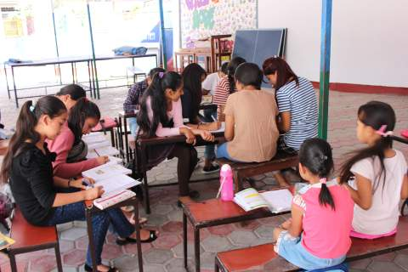 | In this photo some older Nepali high school students are running impromptu classes for primary school students. After the earthquake schools closed down for some time. These classes helped students to decrease their stress and anxiety levels and remove the focus from the devastation .
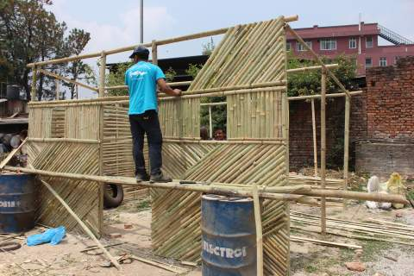 | Many people lost their homes in the earthquake. In this image the Nepali community is banding together to build a new home out of bamboo before the monsoon season. During the monsoon season there is significant amounts of rain and diseases are more likely .
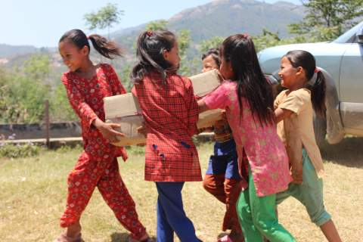 | After the earthquake there was a shortage of food. In this image five local Nepali girls are carrying food that was donated by a Nepali NGO in Kathmandu. This immediate food was needed to ensure that communities did not become malnourished. A group of Nepali teenagers travelled for days to deliver this food.
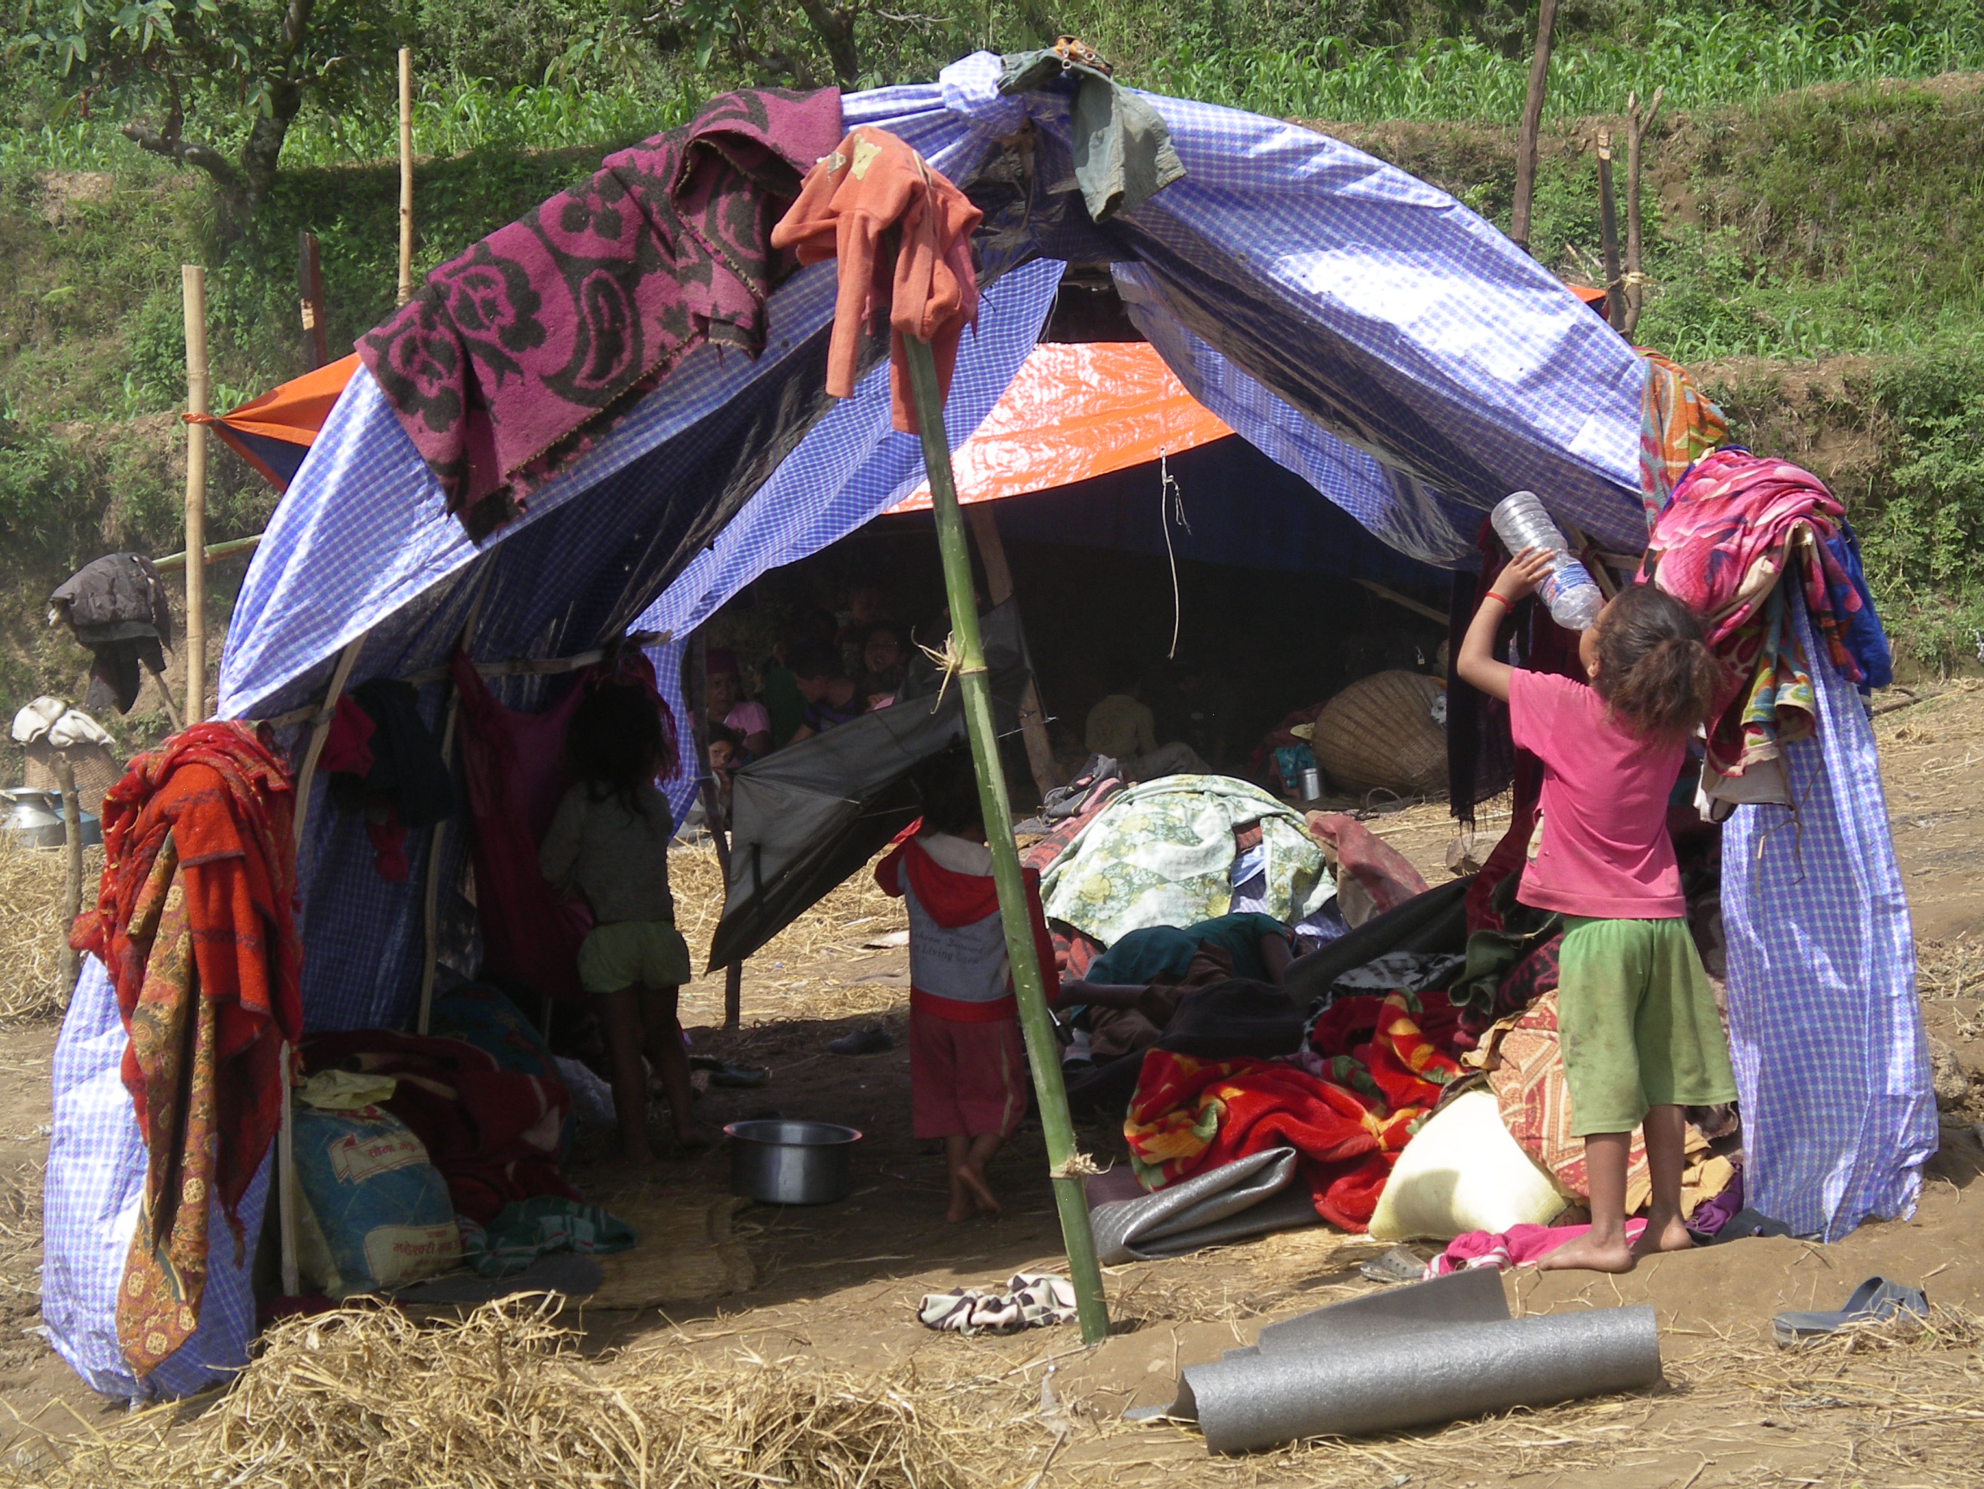 | Many people lost their homes in the earthquake. In this image a make shift house is shown. Many of these temporary houses were not waterproof. Tents were in high demand after the earthquake and these were distributed to many remote communities.

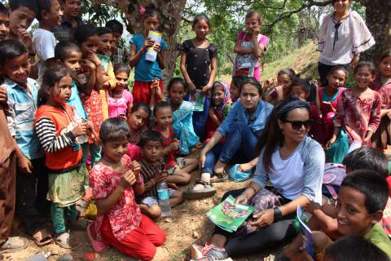 | In this photo some older Nepali high school students are providing basic counselling to children in a remote village. The earthquake was a traumatic experience. These classes helped children to decrease their stress and anxiety levels.
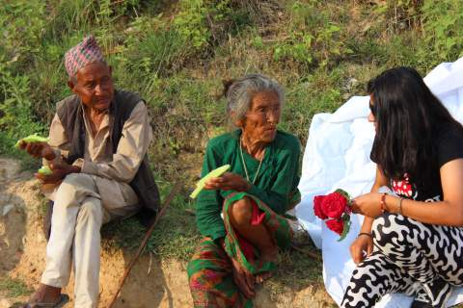 | Many people lost their homes and loved ones in the earthquake. In this image a Nepali teenager is providing food and counselling this elderly couple. After the earthquake sharing the stories of what happened and the impact was a part of healing.
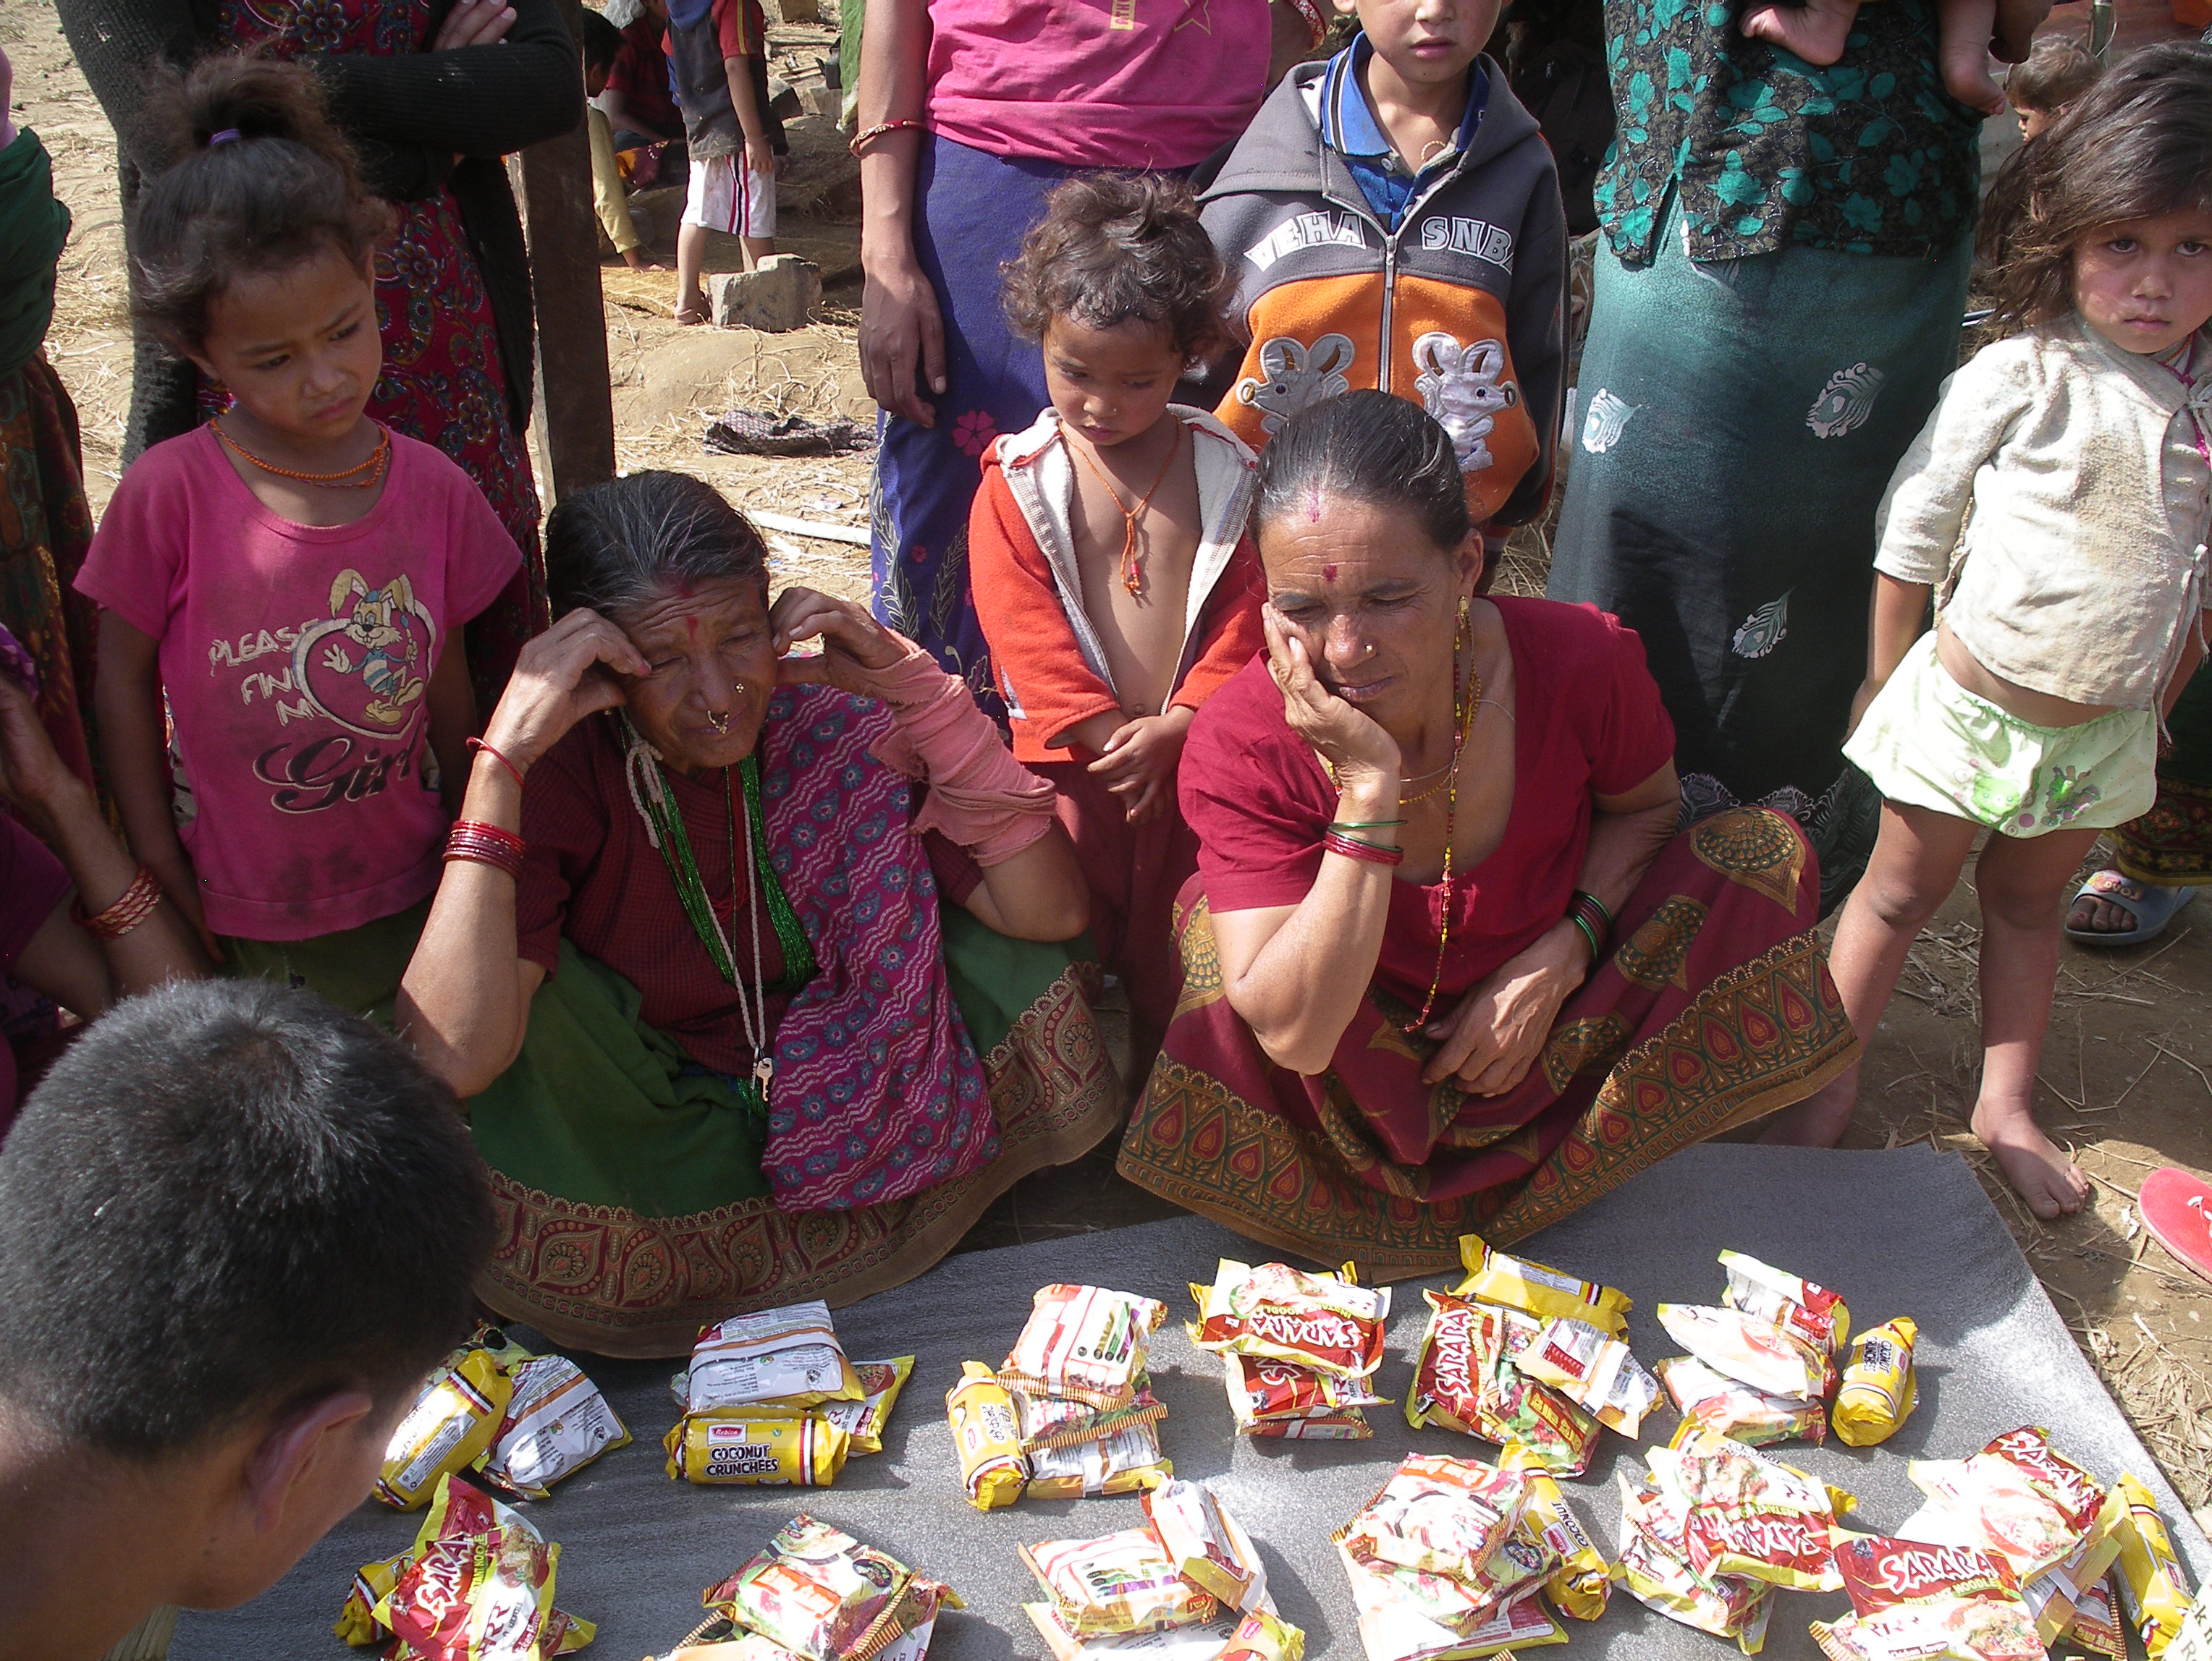 | After the earthquake there was a shortage of food. In this image donated food is being divided among the community. This immediate food was needed to ensure that communities did not become malnourished. A group of Nepali teenagers travelled for days to deliver this food to their community.
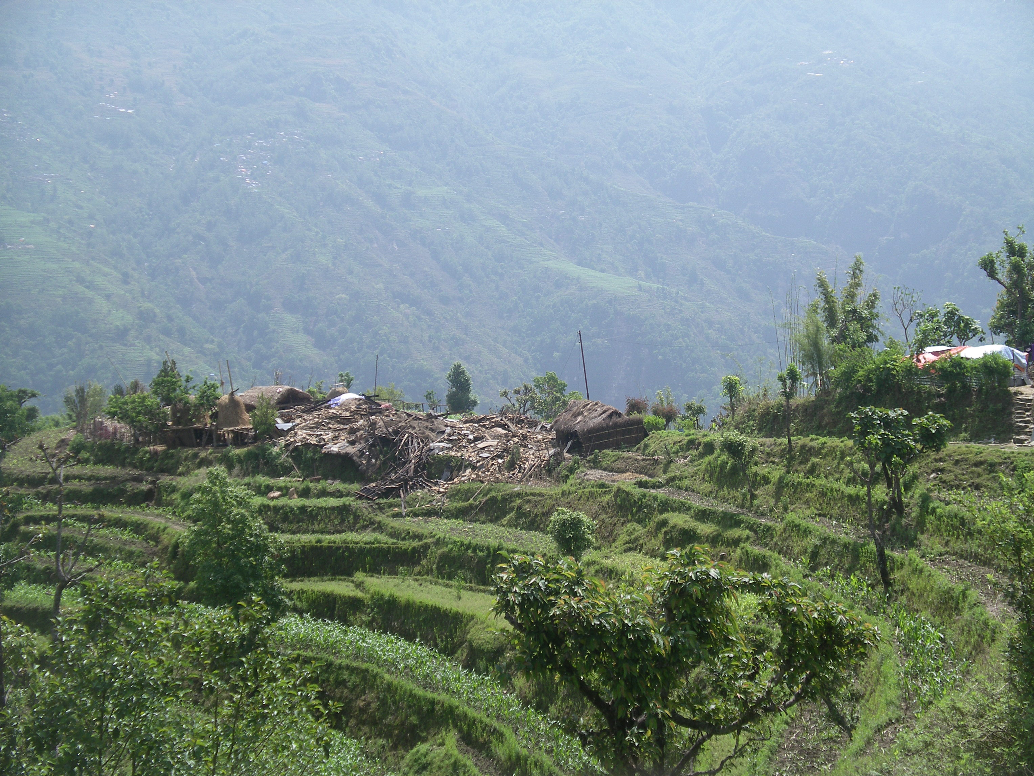 | This image shows the devastation on a remote community. Farmland and irrigation systems were also severely affected by the earthquake. Pipes and new seeds were carried to these areas to assist in the regeneration of the farming community. This loss of farmland affected the food available.

