Heartquake
Primary School Lesson Plan

Art is not what you see but what you make others see - Degas

Overview:

The visual arts can not only produce emotion in those that view and engage with it. The process of creating a work of art can be a therapeutic method for students to harness their emotions, concepts and understandings. Through using photos of the Nepal earthquake to create a piece of artwork students can create their representation of this event and demonstrate their use of colour, creativity and technique.

Objectives:

- To create a meaningful piece of art that reflects the earthquake
- To think creatively
- To view photographs as pieces of art

Australian Curriculum links

ACAVAM115 Develop and apply techniques and processes when making their artworks.

Prerequisites:

- A basic understanding how to use graphite pencils, water colours, paint, collage, charcoal.

Hook:
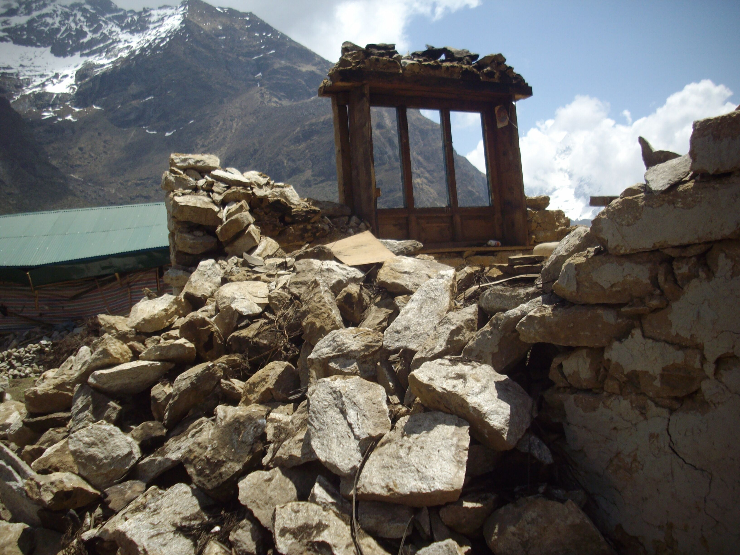
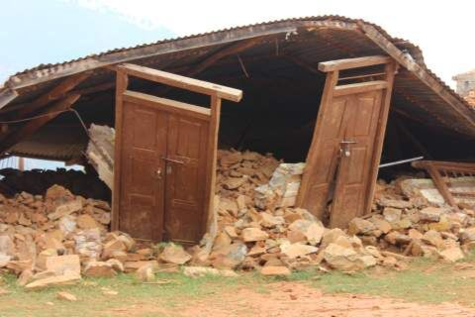

Have these images on the interactive whiteboard. Ask students to look at it for one minute without saying anything. Then ask students what do you think has happened here? How does this picture make you feel? Is this picture art? Why/why not?

Activities:

Slideshow
Place the photos on a slideshow. To create an atmosphere music could be played and/or candles could be lighted. Afterwards ask students which photo evoked the most emotion in them? Which was the most hopeful?

Creating
Set the classroom up with five art stations with charcoal, graphite pencils, water colours, collage and paint. Explain to students that using the photos as inspiration they are to create a piece of artwork and that they can use any medium available. Leave the slideshow going. Provide time for students to create their own artwork giving support when needed.

Art Gallery
Ask students when finished to write and type a short description of their art piece and the process undertaken to create it. When the art is finished and dry either frame or back with black paper and display with the description. This can be shown as a gallery with other pieces of work from the other heartquake lessons. Students can then view the gallery.

Resources:

Heartquake website
Paper, graphite, charcoal, collage items, paste, scissors, paint, paintbrushes, water colours

Assessment/home work:

The students completed artwork and description.

Teacher Notes

Duration of the Lesson:

60 minutes

Topic:  Heartquake | Lesson Heading:  Art is not what you see but what you make others see
Background of the importance of the topic:

The visual arts can not only produce emotion in those that view and engage with it. The process of creating a work of art can be a therapeutic method for students to harness their emotions, concepts and understandings.

Things to think about when preparing your lesson:

Some students can become quite self-conscious in art. Reassure students that art is not about perfection and that it is okay to make mistakes, these just provide opportunities to be more creative.

Challenges which may be faced and coping strategies:
Potential Challenges:  Although some students find having an open task freeing and empowering for others it can be quite daunting. |  | Coping Strategies:  For these students that are struggling ask them to create a quick plan, this will help provide them with focus.
Useful tips:

Place the painting stations closest to the sink to allow for an easy clean up.

Useful resources:

- http://www.australianphotography.com/
- https://www.acp.org.au/

